Replication Instructions

For questions, contact Pardee.Institute@du.edu.
This document contains instructions to reproduce the IFs modeling portion of the article The Geopolitics of Decarbonization: Renewable Energy Transitions and International War. It walks users through the setup of IFs then provides instructions for how to reproduce and view the results. To replicate our statistical analyses, please see the “StatisticsReplicationFiles” folder.

Table of Contents
Download Required Files 1
Installing IFs 1
Preparing IFs 1
Reproducing Monadic Results 4
Reproducing Aggregated Dyadic Results 5
Reproducing Directed Dyadic Results 7
Suggested Forecast Variables 9

Scenario Key: Scenario options are indicated with the format “Ygw[Fos/Ren]X_0” where the X takes a numeric value of 0 (indicating the full model), 1 (indicating the trade only model), or 2 (indicating the democracy only model) and the Y takes the value of either e (indicating no PRDs, all dyads considered relevant) or pe (indicating dynamic PRDs are active).
The sensitivity scenario runs have a prefix appended to the beginning of the scenario name where: “ne” indicates no exogenous series (no imposed external forecasts), “rsw05” indicates that the assumption of proportional reductions has been weakened to half the full 1-to-1 imposed reduction, and “rsw0” similarly indicates that the assumption has been removed.
Steps to Reproduce:
- Download Required Files
  - Download Version 8.47 of IFs:
    - Direct Download Link – https://ifsfiles.du.edu/IFs%20with%20Pardee%208_47%20Bilateral%20June%2010%202025.zip
    - Indirect Download Link – https://ifsfiles.du.edu/
Download “IFs with Pardee 8_47 Bilateral June 10 2025.zip” by clicking on it in the list.
  - Necessary Files: Included alongside these instructions in the folder “IFsReproduction”.
  - Unzip these files to an easy to access location. You may delete these files from this secondary location after importing them to IFs.

- Installing IFs
  - Extract the ZIP file to a desired location.
  - Run the installer “IFsSetup.exe” as an administrator by right clicking and selecting “Run as administrator”
  - Follow instructions and prompts
  - Remember the location to which you have installed IFs. File paths in later steps will use “…” to refer to your individual folder location.
- Preparing IFs
  - Importing Group
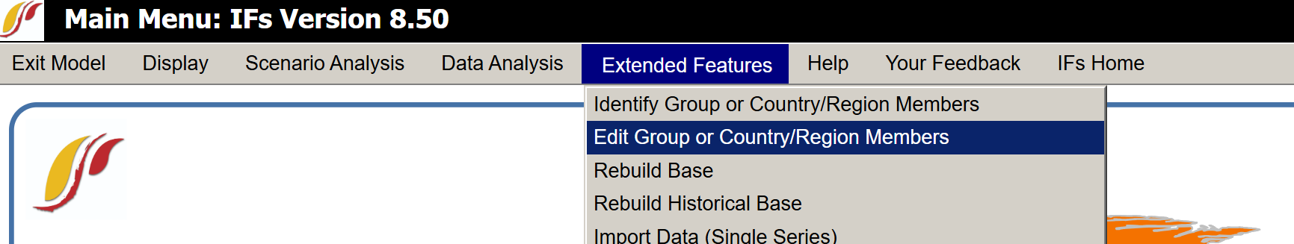
    - Select the “Edit Group Country/Region Members” from under “Extended Features” on the main menu’s selection bar:
    - Select the file “VarListTransmission.db” by clicking the highlighted location in the bottom right corner and navigating to the appropriate location (the file location to search for will be wherever you have extracted the zipped necessary files):
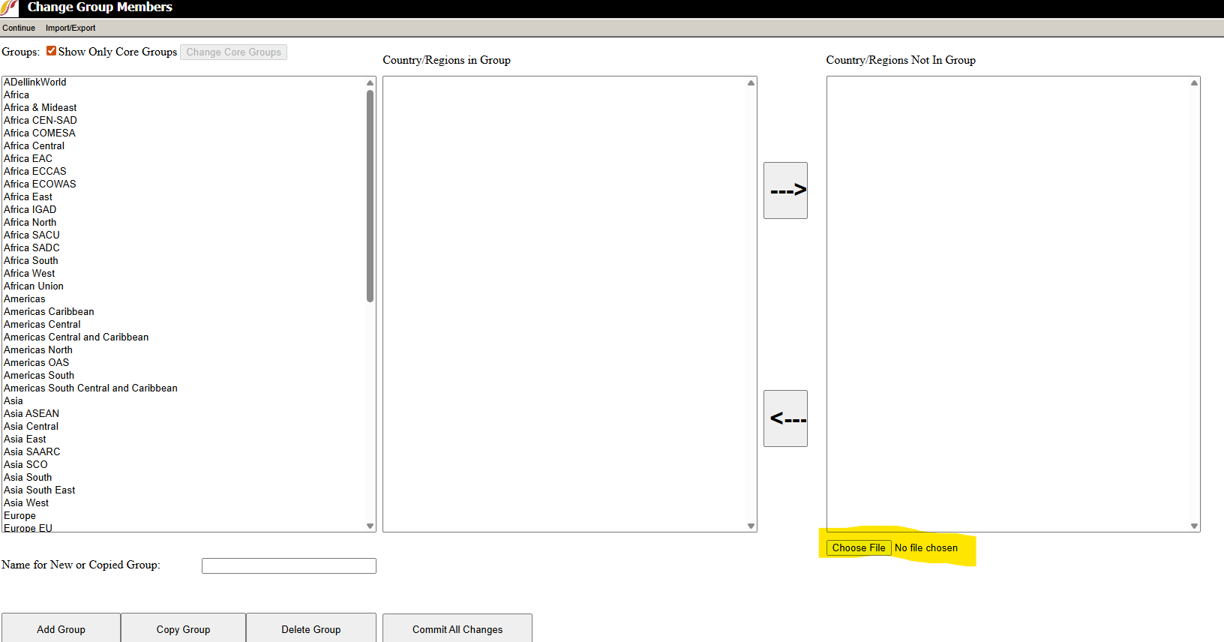
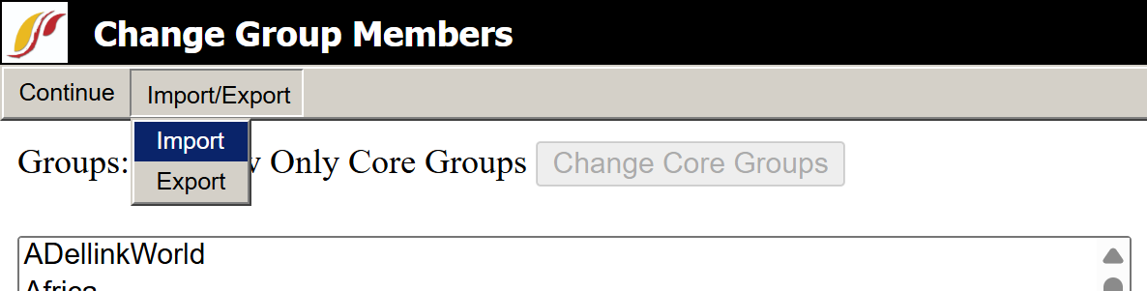
    - Click import from the selection bar at the top:
    - Click “Commit All Changes” on the bottom in the center of the screen:
    - Select “Continue” to return to the main menu.

  - Importing Run Files
    - Copy the files included in the necessary files from the location you chose to extract them and paste them in the “RUNFILES” folder located at “…\IFs\RUNFILES\”.
  - Update Aggregation Rules
    - Copy “IFsVar.db” from the necessary files and place the copy within the folder “…\IFs\DATA\”

  - Import Variable List
    - Select “Flexible Displays” from under “Displays”
    - Select “Edit Lists” from the top menu bar
    - Select the “Choose File” option (highlighted in screenshot below) and select “VarListTransmissionVariableList.db” from the location that you unzipped the necessary files
    - Select “Import Selected File”
    - Select “Save Changes” and then “Exit”
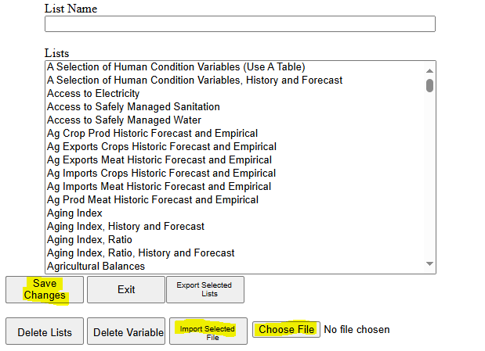

  - If IFs is already open, please restart IFs to ensure the changes to take effect. This will include restarting IIS to make sure all Session variables are reset (Go to Windows search for IIS, open the console and click the Restart green option on the right).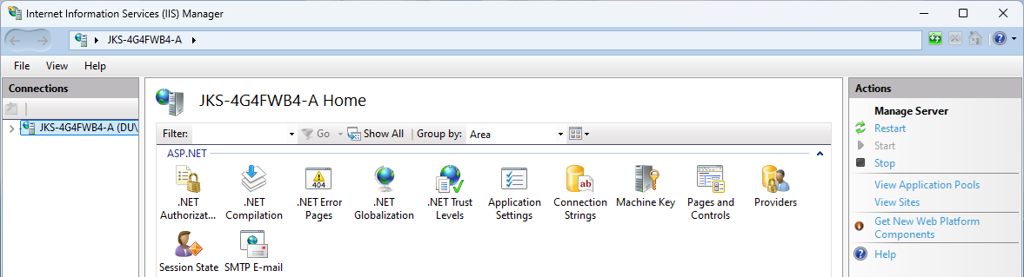
- Reproducing Monadic Results
  - From the main menu, select “Flexible Display” from the selection bar at the top of the screen’s “Displays” heading:
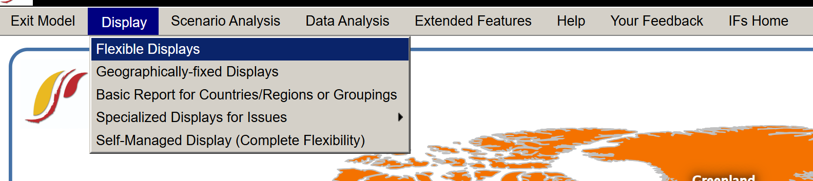
  - Select the most applicable section from the leftmost panel “Display Categories”. Highlighted yellow. Here, we will use Gross Domestic Product (GDP) as an example, so select “Economy GDP”. A list of recommended variables is included at the end of this document.
  - Select “GDP (MER) – Billion dollars”. Highlighted orange.
  - Select countries/groups of interest from the rightmost panel. Highlighted purple. Hold control on your keyboard to select multiple.
  - Select scenarios from the bottom-middle panel, which is highlighted pink in the screenshot below.
    - To compare results across the paired scenarios, hold control while selecting scenarios to select and maintain consistent ordering (selecting the renewable or the fossil scenarios)
  - If desired, change the end year to display from the “Horizon” panel in the bottom left corner. Highlighted teal.
  - Select “Table” or “Line Graph” from the bottom left to view results.
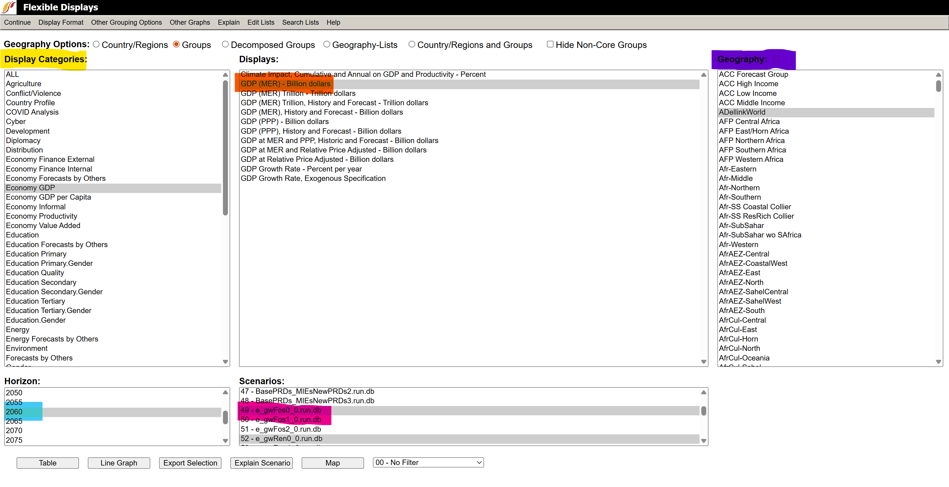

- Reproducing Aggregated Dyadic Results
  - Follow the instructions form before. This section will use the data underlying figure three from the manuscript as an example.
  - Under “Display Category” select “International Politics”
  - Select “Dyadic Threat of Conflict – Probability of militarized dispute” from the displays list in the middle panel.
  - From the radio buttons for “Geography Options” select the “Groups” option.
  - Select “ADelinkWorld” for both “Geography” and “Second Dimension”.
  - Select “Table”. The screenshot below is provided for reference to the above selections:
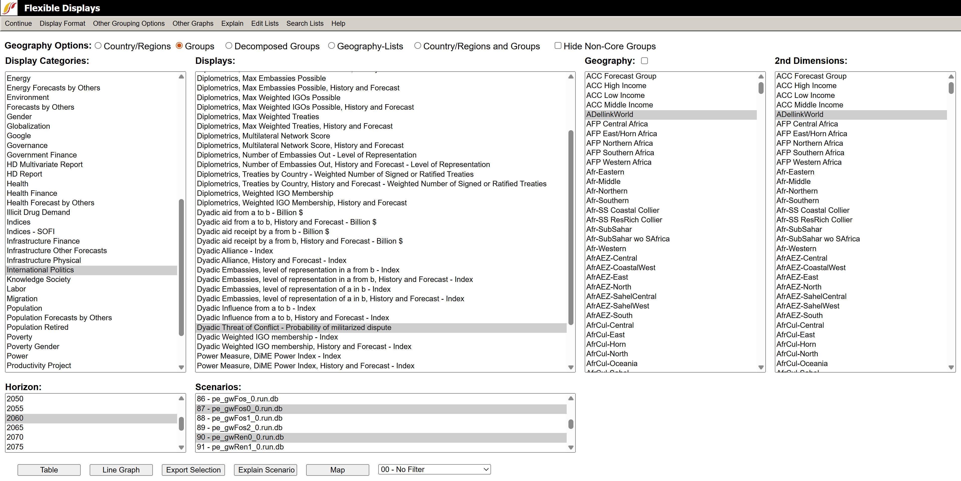
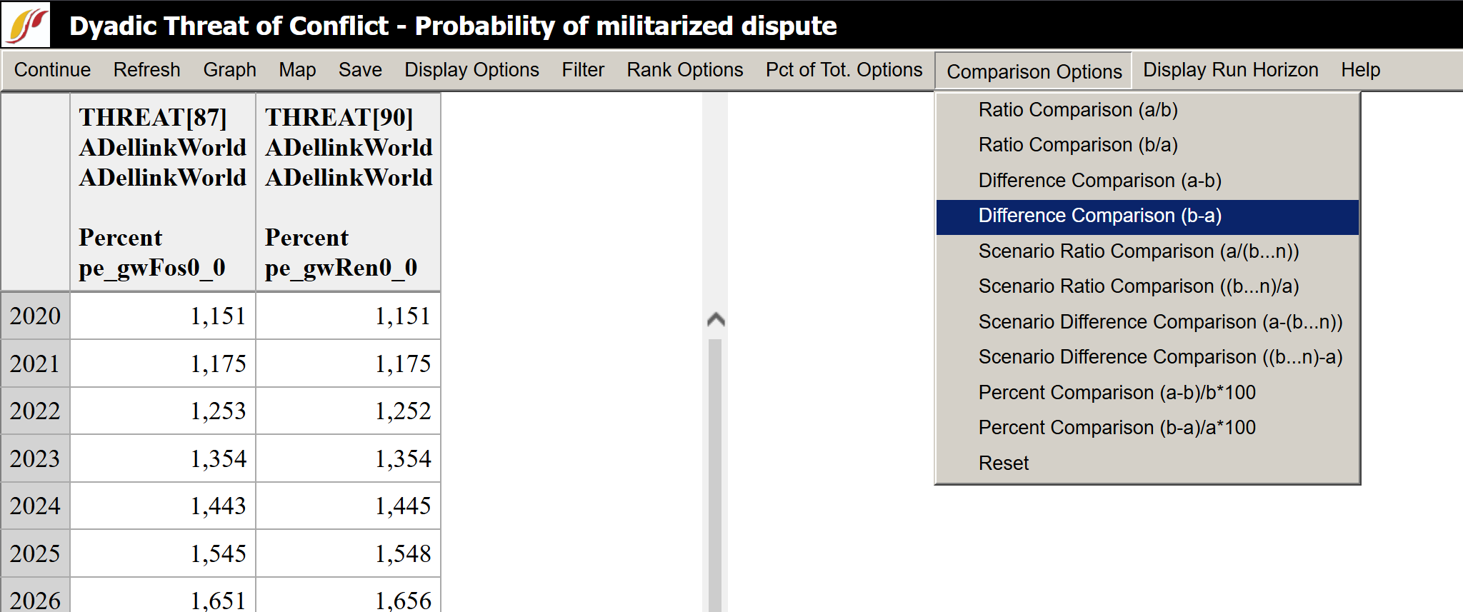
  - Select “Comparison Options” from the top menu bar. Then select the appropriate A-B/B-A difference comparison:

  - Select “Display Options” from the top menu bar. Hover over cumulative and select “On” when it appears:
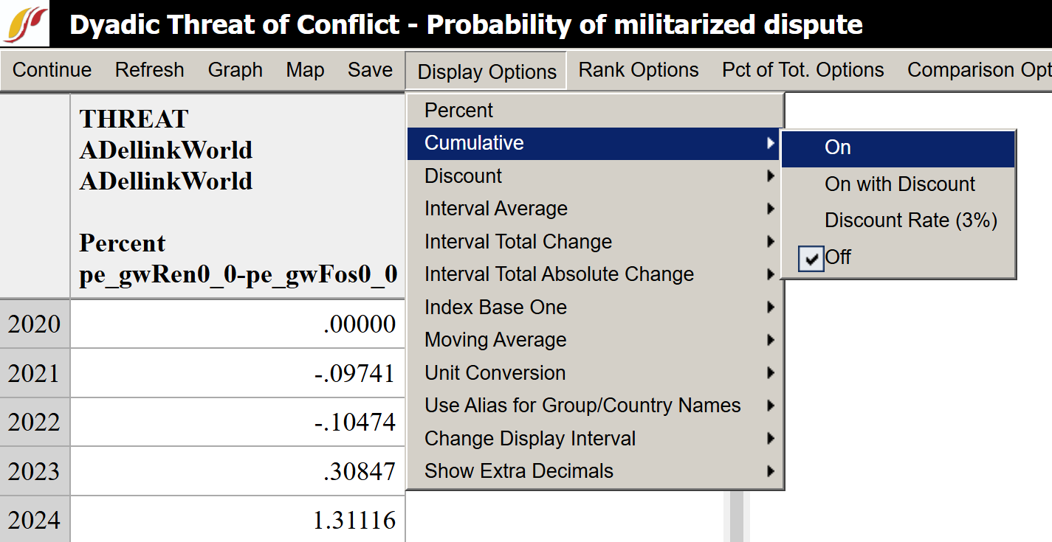

  - Select “Graph” or “Save” to view results or export them for further use.
- Reproducing Dyadic Results
  - Navigate to Flexible Display per prior instructions
  - From the radio buttons for “Geography Options” select the “Decomposed Groups” option.
  - Select “Dyadic Threat of Conflict – Probability of Interstate Dispute” from the displays.
  - Select desired countries for “Geography” and “Second Dimension” by holding control and clicking. To select continuous sections of countries, hold control + shift then click on the starting and ending countries. Geography refers to the country of origin and the “Second Dimension” refers to the targeted country.
    - For other variables, “Geography” refers to the country of origin for exports and the country of destination for imports.
  - Select a single scenario for export at a time.
  - Click “Export Selection” to export for use in external software for analysis:
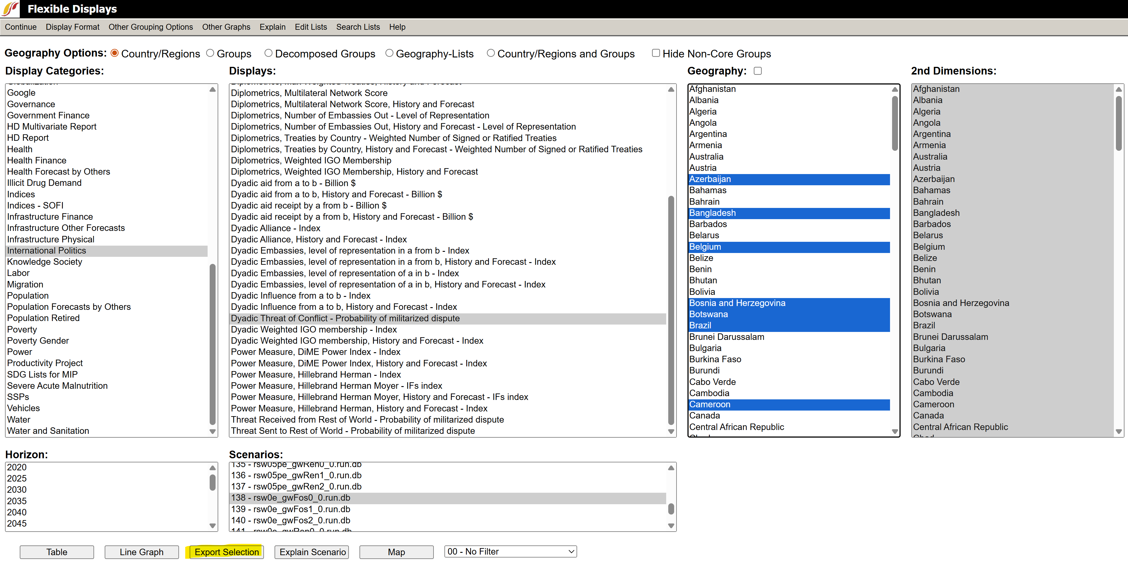

Suggested Forecast Variables:
Dyadic THREAT – located under International Politics with the name “Dyadic Threat of Conflict – Probability of Interstate Dispute”
Dyadic Trade – located under Economy Finance External with names like “Dyadic Energy Imports by a from b – Billion $” and “Dyadic Energy Exports by a from b – Billion $”.
Energy Exports – located under Economy Finance External with the name “Exports by Sector, Value – Billion USD”. Select energy in the rightmost panel for results reported.
Trade by Sector as Percentage of GDP (Monadic/Single Country) – located under Economy Finance External under the name “Exports, Value by Sector – Percent of GDP”
GDP – located under Economy GDP with the name “GDP (MER) – Billion dollars”

